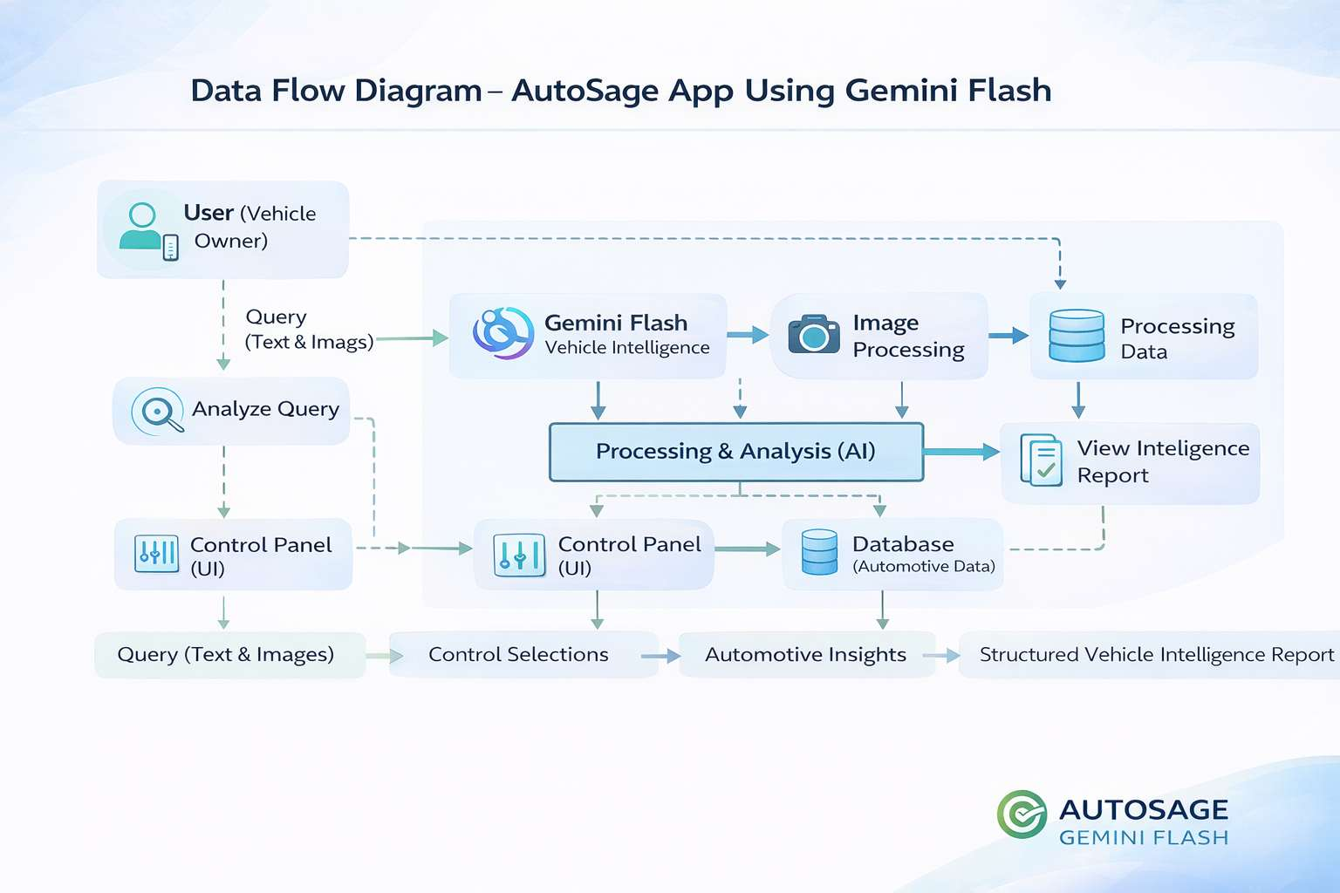

Project Design Phase-II

Data Flow Diagram & User Stories

Date | 06 February 2026
Team ID | LTVIP2026TMIDS88090
Project Name | AUTOSAGE APP USING GEMINI FLASH
Maximum Marks | 4 Marks

Data Flow Diagrams:
A Data Flow Diagram (DFD) is a structured visual representation that illustrates how information flows within the AUTOSAGE APP USING GEMINI FLASH system. A clear and well-organized DFD graphically represents system requirements by showing how user inputs (text, images, and control selections) enter the application, how the Gemini Flash AI processes and transforms the data, and how structured vehicle intelligence reports are generated as output.
Example: DFD Level 0 (Industry Standard)

Example: (Simplified)
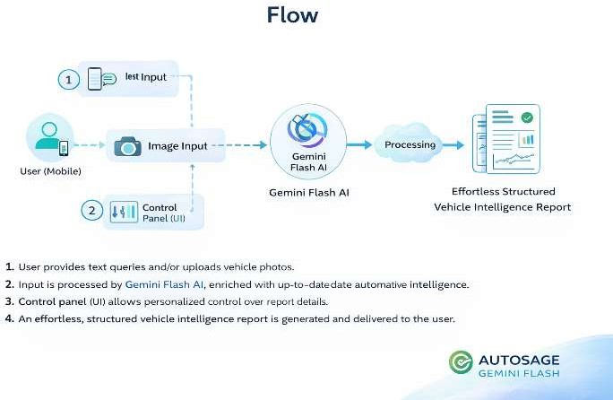

User Stories
Use the below template to list all the user stories for the product.

User Type | Functional  Requirement (Epic) | User Story Number | User Story / Task | Acceptance criteria | Priority | Release
Customer (Web User) | Registration | USN-1 | As a user, I can register using email and password. | User account created and redirected to dashboard. | High | Sprint-1
Customer (Web User) | Registration | USN-2 | As a user, I receive a confirmation email after registration. | Confirmation email received and account  verified. | High | Sprint-1
Customer (Web User) | Login | USN-3 | As a user, I can log in using email and password. | Successful login redirects to dashboard. | High | Sprint-1
Customer (Web User) | Smart Query | USN-4 | As a user, I can enter a vehicle-related query to generate an intelligence report. | Structured vehicle  intelligence report is displayed. | High | Sprint-1
Customer (Web User) | Image Analysis | USN-5 | As a user, I can upload a vehicle image for analysis. | Structured vehicle  intelligence report is displayed. | High | Sprint-1
Customer (Web User) | Multimodal Analysis | USN-6 | As a user, I can upload an image and provide text input together. | AI generates structured report based on image. | High | Sprint-2
Customer (Web user) | Control Panel | USN-7 | As a user, I can select vehicle type and purpose from sidebar controls. | Selected filters affect generated report. | High | Sprint-1
Customer (Web User) | Apply Settings | USN-8 | As a user, I can apply selected sidebar changes before analysis. | Selected filters affect generated report. | Medium | Sprint-1
Customer (Web User) | Apply Settings | USN-9 | As a user, I can apply selected sidebar changes before analysis. | Changes are reflected in generated output. | High | Sprint-1
Customer (Web User) | Error Handling | USN-10 | As a user, I receive warnings if prompt or image is missing | Proper validation messages are displayed. | High | Sprint-1
Administrator | Model Configuration | USN-11 | As an admin, I can configure Gemini API settings securely. | API key stored securely and model responds  correctly. | High | Sprint-2
Administrator | Performance Control | USN-12 | As an admin, I can adjust temperature and token limits. | API key stored securely  and model responds correctly. | Medium | Sprint-2
Administrator | Monitoring | USN-13 | As an admin, I can monitor AI usage and system | Model configuration changes reflect in  responses. | Medium | Sprint-3

